ARTICLE TITLE
Yazar/Author¹ , Yazar/Author², Yazar/Author³

^{1,2}Bandırma Onyedi Eylül Üniversitesi, Mühendislik Fakültesi, Bandırma, TURKEY
³ Bandırma Onyedi Eylül Üniversitesi, İktisadi ve İdari Bilimler Fakültesi, Bandırma TURKEY

corresponding_author@bandirma.edu.tr
Corresponding Author ORCID

ABSTRACT
Abstracts in Turkish and English must be included in the submitted papers. The abstract should be prepared in Times New Roman font with 12 pt. The abstract should be at least 250 words and should not exceed 750 words. For foreign participants, only an ENGLISH ABSTRACT is required.Abbreviations should not be used in this field. The abstract should include the purpose, method, findings and results information and information about the study. Abstract title should be written in capital letters, centered. "Keywords:" should be written in italic, in 12 pt., with one line space after the abstract. Each word of keywords must begin with a capital letter.
For papers to be sent as full paper, the formatting of the table, figure, equation, graphic and bibliography given below should be used.
Keywords: Microgrid, Wavelet, Travelling Wave

1.1. Sample Table
Table 1. Sample Table
Shop floor | Shop floor 1 | Shop floor 2 | Shop floor 3
# of machines | 20 | 30 | 40
# of Jobs | 50 | 100 | 200

Sample Figure
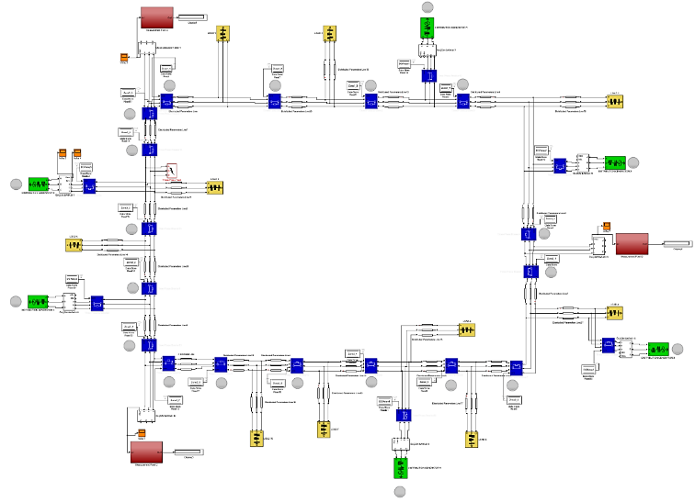
Figure 1. Sample Figure

Sample Graphic

Graphic 1.

Mathmatical Furmula, Equations, Symbols and abbreviations
$\int{\frac{-b±\sqrt{b^{2}-4ac}}{2a}}e^{-iωt}\frac{Δy}{Δx}\frac{∂y}{∂x}\sum{\frac{π}{2}}$ (1)

Conclusion

References
- G. Pevere. “Infrared Nation.” The International Journal of Infrared Design, vol. 33, pp. 56-99, Jan. 1979.
- A. Altun, "Understanding hypertext in the context of reading on the web: Language learners' experience," Current Issues in Education, vol. 6, no. 12, July 2003. [Online]. Available: http://cie.ed.asu.edu/volume6/number12/. [Accessed Dec. 2, 2004].
- B. Klaus and P. Horn, Robot Vision. Cambridge, MA: MIT Press, 1986.
- L. Bass, P. Clements, and R. Kazman, Software Architecture in Practice, 2nd ed. Reading, MA: Addison Wesley, 2003. [E-book] Available: Safari e-book.
- L. Stein, “Random patterns,” in Computers and You, J. S. Brake, Ed. New York: Wiley, 1994, pp. 55-70.
- J. O. Williams, “Narrow-band analyzer,” Ph.D. dissertation, Dept. Elect. Eng., Harvard Univ., Cambridge, MA, 1993.
- D.B. Payne and H.G. Gunhold. “Digital sundials and broadband technology,” in Proc. IOOC-ECOC, 1986, pp. 557-998 bildiri
- B. Brandli and M. Dick. “Engineering names and concepts,” presented at the 2nd Int. Conf. Engineering Education, Frankfurt, Germany, 1999.

